2021 Federal MP Brief
Background:
Current maternity spending by government is about $7 billion per year. The current birth rate is around 300,000 births per year.

Outcomes:
. Despite having such high financial input, outcomes are relatively poor:
- 1/3 women have birth trauma. 2/3 of this is due to disrespectful treatment
- Only 8% of women can access continuity of midwifery carer- the best type of maternity care
- Caesarean rate 36% - more than double the recommended rate by WHO
- 43% of low risk women having their labour induced. Many are reporting not having informed consent
- 11-fold variance in 3rd/4th degree tears
- Preterm birth rate of aboriginal babies is between 2 and 7 times that of non-indigenous babies and continue to die suddenly and unexpectedly at a rate 3.5 times higher than their non-Indigenous counterparts.

Solutions:
- Increase continuity of midwifery carer to:
-Reduce unnecessary intervention
-reduce preterm birth rate and infant mortality for Aboriginal women and babies
-increase breastfeeding rates
-reduce birth trauma and PNDA
This is outlined in the 2019 National Strategy for Australian Maternity Services. The Federal Government provides continuity of midwifery carer to women via private midwives.
- Bundled Funding as suggested by IHPA in 2017, national strategy in 2019 and MBS review of Participating Midwives report in 2019
- Published data on hospital and clinician outcomes including: Patient Reported Experience Measure and Patient Reported Outcome Measures.

Woman Centred Care:
To ensure regular monitoring and evaluation of the National Strategy for Australian Maternity Services, consumers need to be involved through consultation and decision-making processes.

Contact: Alecia Staines
Director- Maternity Consumer Network
0401033348 management@maternityconsumernetwork.org.au
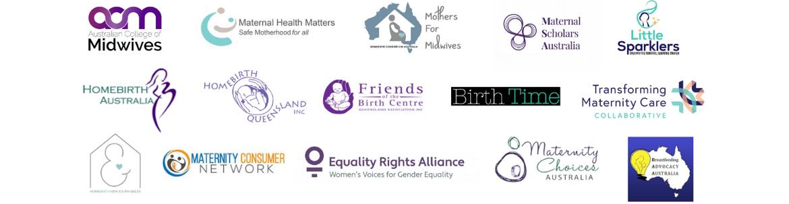
Endorsed by:

